Low cost AI based Autonomous Mobility Scooter

Abstract: Often physically challenged people have problems navigating to places on their own without any assistance from peers. Availability of people for assistance cannot be guaranteed all time. Hence, in this modern world of autonomous systems where computers make decisions using AI we have developed an AI based autonomous mobility scooter that can be used by people with special abilities or a person with normal abilities to navigate to their desired destination.

SI.No | Title | Page
1 | Abstract | 1
2 | Introduction | 2
3 | Hardware Architecture | 3
4 | Software Architecture | 5
5 | AI | 7
6 | Obstacle Avoidance | 8
7 | Challenges Faced | 9
8 | Result | 10

Introduction:
With the advent of autonomous vehicles, many researchers are focusing on developing autonomous robots that can assist the physically challenged like the blind or people without limbs to navigate to their desired destination with ease. Most of the existing solutions of mobility scooters have sensors that cost $ 4k each are hence are not affordable for people under moderate income group. The solution offered by this project is a low-cost AI based autonomous scooter that is affordable. Key part that makes it affordable is the computer on board that is Jetson TX2 that is three times cheaper that conventional GPU computers used in AI based autonomous vehicles and the low-cost sensors. The solution provided here is a complete travel solution for indoor and outdoor navigation for people who need mobility assistance.

Architecture:
Hardware:
The compute engine of the autonomous scooter is a Jetson TX2 and an Arduino UNO. Jetson TX2 is the on-board computer responsible for data processing, handling AI and decision making, providing commands to other modules in the system. The Jetson TX2 us powered by a 50000mAH power bank at 12v. Sensor module consists of RPLidar, Zed stereo vision, Inertial Measurement Unit, Encoder, Digital to analog converter. The RPLidar is responsible for the mapping for indoors, ZED camera is the key part of the vision-based AI system and IMU data, encoder data are used with a sensor fusion to provide odometry.
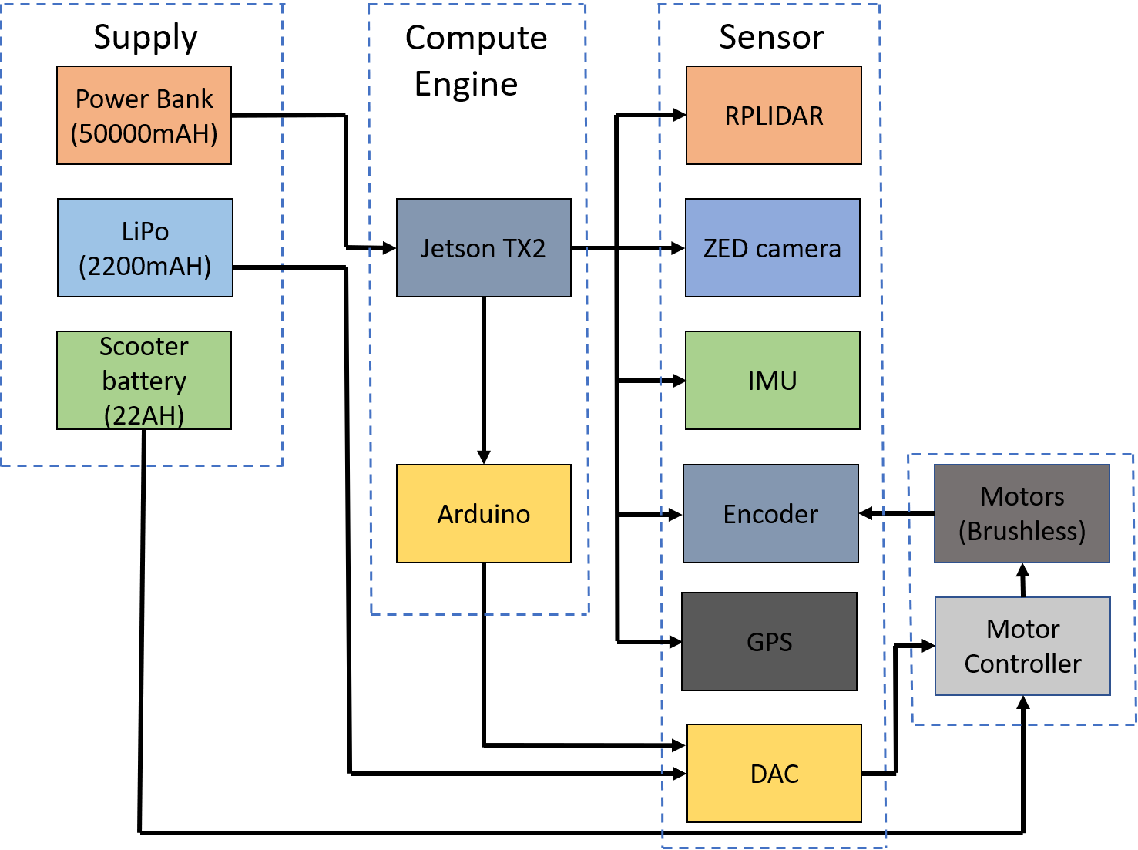
Figure 1
The encoder used for this project has a resolution of 1024 pulses per rotation. The Inertial Measurement Unit used for this system is a RAZOR IMU with 9 degrees of freedom that provides accelerometer, gyro and magnetometer data. The Digital to analog converter here is used to generate analog voltage for the throttle and direction control of the scooter using the PWM commands received from the Arduino UNO. The output range of Digital to Analog converter used in this project is 0 – 6 V.
The Digital to analog converter receives its power from a 2200mAH Lithium polymer battery. The scooter is driven by two brushless motors and a brushless motor controller that is powered by a 22AH battery.
Software:
Software architecture of the autonomous scooter is shown in Figure 2. The Jetson TX2 computer is the master controller for the autonomous scooter that runs Ubuntu 16.0.4. ROS kinetic is used on the Jetson to develop navigation, mapping, obstacle avoidance and handle the camera system. There are two modes of driving for the autonomous scooter that us the indoor mode that uses LIDAR, Odometry, map server package to provide map information and AMCL and the outdoor mode that uses Odometry, android app and GPS for navigation.
Indoor Mode: The indoor mode uses RPLidar to map the environment in 2-dimensional plane using Hector SLAM and use the stored map to navigate using AMCL (Adaptive Monte Carlo localization). This AMCL along with move base is used to localize the scooter using Lidar data and odometry and move based further develops the navigation route for the given destination on the MAP being published.
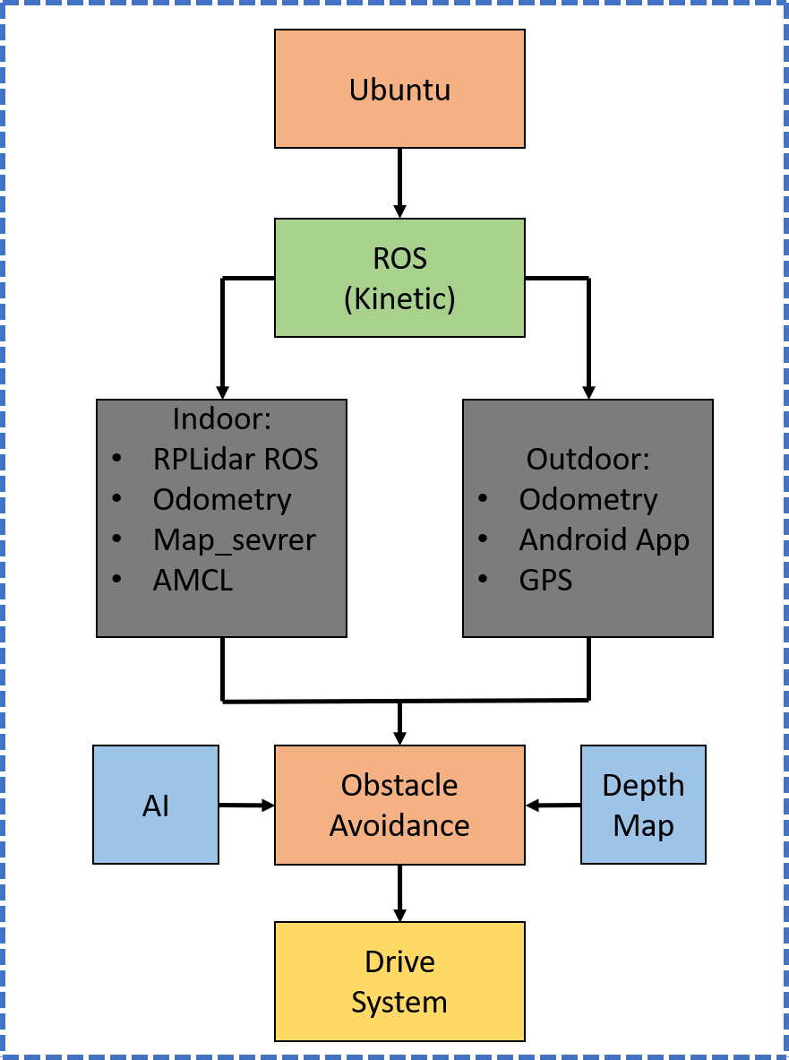
Figure 2
Outdoor Mode: This mode involves use of GPS module and an android application that provides information using google maps API about the route and provides the latitude and longitude information for intermediate checkpoints between the source (provided by the GPS) and the destination chosen by the user on the android UI.
The Odometry information is further used to find out the path of travel for the scooter.

AI:
We have an AI system that uses CNN based object detection model to find the objects in the view of camera and decide based on the detected object class and closeness. The AI system mentioned in the project is a CNN model based on Yolo architecture with lesser classes, lesser number of layers developed in darknet with a small tradeoff between [accuracy, Map, recall] and latency. The key reason behind developing the AI system was to provide the ability to the robot to not only detect an obstacle but to know what is in front of it and then make an effective decision. As an example, consider an old man walking in front of the scooter and a chair placed in front of the scooter. The wheelchair can leave the chair un-disturbed and navigate while if it does the same for the person, it might frighten the person instead. For the case of live obstacles, the wheelchair needs to stop and divert its path with sufficient space so that it does not frighten live obstacles like Humans, animals.
Though models like Yolo, Single Shot detector are already available for use today, the performance on Jetson TX2 was not real-time and had a latency that prevents it from being a used for a real-time case where detection and reaction takes over one second.

Obstacle avoidance algorithm:
The performance of AI system depends on the image quality and noise in the image, frames. Misclassifications was observed for scenes with heavy lighting or extremely low lighting environments. To avoid absurd behavior while navigation due to the AI systems response, the project involves a fusion of depth data and result from AI model to make decision. Considering a scenario of misclassification where a chair has been detected by the model, the mobility scooter without this algorithm should stop for every obstacle detected in the drive field of view of the scooter and hence the scooter will not be able to navigate in the corridor even in the absence of obstacle if misclassification occurs in case of white, bright corridors. The scooter makes wrong decisions based on the misleading data. However, if the depth data is considered and an obstacle is detected in the corridor while being present within the threshold distance which is 3 meters in this case, the scooter knows that depth camera has detected some object and the class of the object is predicted by the deep learning model. The AI system is hence validated using the depth data to confirm presence of obstacle and then take the necessary action. In the case of misclassification or case where object is falsely being detected on an empty corridor, the depth data confirms absence of any nearby obstacle in the bounding box region and hence the scooter is permitted to navigate instead of rerouting its path.

Response for different kinds of obstacles:
Human or animals: - Stop, take a steep turn providing enough space and then navigate.
Furniture or other non-living obstacles other than sign boards: - slowdown and turn, reroute
Sign Boards: – Read text using OCR and then follow. (this work is under construction)
Challenges Faced:
In this project the cost of construction of the project has been traded off for the range and quality of sensors used. The LIDAR used for autonomous scooters in research today cost $ 4K or more that provide 3D point cloud data with greater range (20m) and the use of multiple sensors in such scooter have improved the way they navigate.
Lidar: The autonomous scooter mentioned in this project uses RPLidar that has a restricted range of 6 meters and works at 10Hz that is insufficient to map long or wide corridors. The LIDAR rate is responsible for the inability to map long corridors and the wavelength of the Lidar restricts it from being used for outdoors. Due to these limitations the scooter cannot navigate in wide corridors (greater than 4 meters) and corridors made of glass walls.
Camera: The sensor used for obstacle avoidance is ZED stereo vision that has noticeable error after 6 meters range and hence cannot be used for long range sensing. The camera also fails to provide correct depth information when solid white shiny surfaces are placed in front of the camera.
GPS: GPS has issues providing accurate current location at times and loses or provides random data rarely that is a noise to the system misleading the system and hence leading to deviated navigation path. Sudden change in magnetometer values have been noticed when the environment has current carrying conductors or magnetic metal is found around the path. This change in magnetometer has been observed to change the path of the scooter in some cases.
The issues mentioned above are being worked on and will be addressed soon.
Results:
Version 1: https://www.youtube.com/watch?v=IiVDCXaql7A (Without AI)
Version 2: https://youtu.be/wOLoUwOkiaI

